

Dr Charlotte Tye, EDiTS Study, Institute of Psychiatry, Psychology & Neuroscience, PO80,

De Crespigny Park, London, SE5 8AF

Email: [edits-study@kcl.ac.uk](mailto:edits-study@kcl.ac.uk)

Website: [www.edits-study.org](http://www.edits-study.org)

Phone: 0207 848 5388/ 07495 550118

**Infant Eye Tracking Information Sheet**

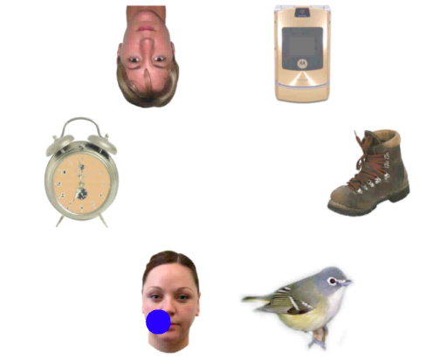

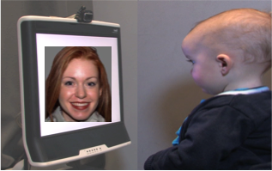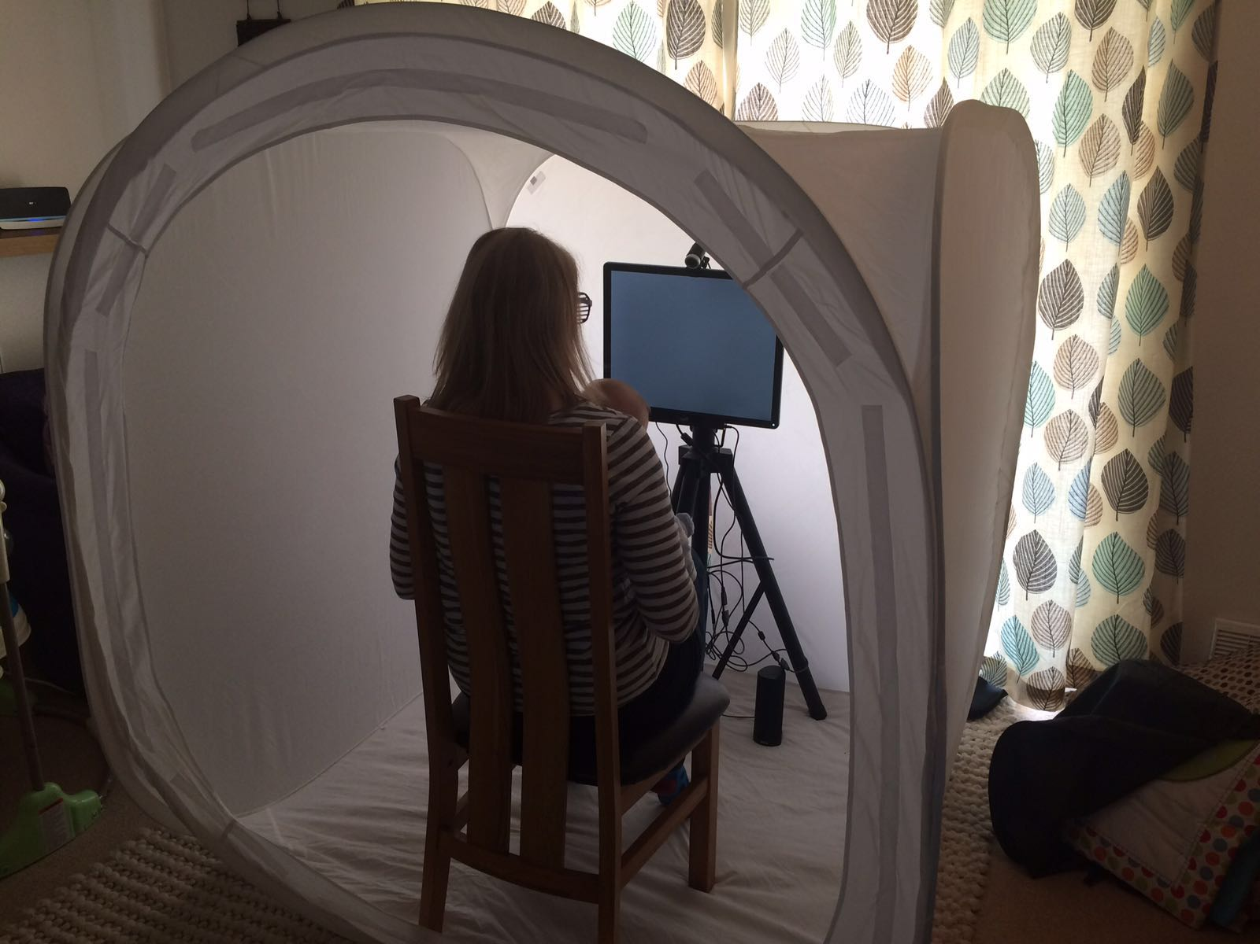

*Baby in front of the eye-tracker and example of gaze data. The blue dot is where the baby was looking on the screen at a particular moment.*

Eye-tracking has been used for many years to understand attention and perception in infancy. The eye-tracker allows us to see exactly where the baby is attending on the screen. With this method we could confirm that babies prefer to look at faces (image on the right) and that they can match language with the lip movement that produced it (image on the left).

The eye-tracker looks like a normal computer screen with the difference that it has incorporated a few light-emitting diodes. These emit infra-red light in a similar way to the light emitted by a camera in order to prevent the “red eyes”, when using flash. The intensity of the light used is very small and is therefore harmless.

Once your baby is seated on your lap about 60 cm from the screen, we have to “calibrate” the eye-tracker. To do this, we present short animations on different parts of the screen and wait for your baby to look at them before taking a measurement. This will tell the machine the distance between baby’s eyes (which varies from person to person). Sometimes we may need to do the calibration a few times, in case the baby has moved or not looked at one of the calibration points.

Once we have a good calibration, we’re good to go! We will show your infant pictures or videos until the study is finished or your baby becomes bored or fussy. You can ask us to take a break or stop at any time.

Please do not hesitate to ask any questions you have about this method.